Theory:
In numerical methods and measurements, errors represent the difference between the measured or estimated value and the actual true value. Since no measurement or computation is perfectly exact, understanding different types of errors is important in engineering and scientific practice.
- Absolute Error (AE):
The absolute error is the direct difference between the measured value and the true value. It indicates how much the measurement deviates in physical units.
Formula: AE = |Measured Value – True Value|
- Relative Error (RE):
The relative error is the ratio of the absolute error to the true value. It gives an idea of how significant the error is compared to the size of the quantity being measured.
Formula: RE = Absolute Error / True Value
- Percent Relative Error (%RE):
The percent relative error expresses the relative error as a percentage, making it easier to interpret in terms of accuracy.
Formula: %RE = (Relative Error × 100)
Example in this experiment:
- Measured diameter = 50.02 mm
- True diameter = 50.00 mm
- Absolute Error = 0.02 mm
- Relative Error = 0.0004
- Percent Relative Error = 0.04 %
This shows that although there is a small difference in measurement (0.02 mm), the relative error is very low compared to the true size, meaning the measurement is highly accurate.

Code:
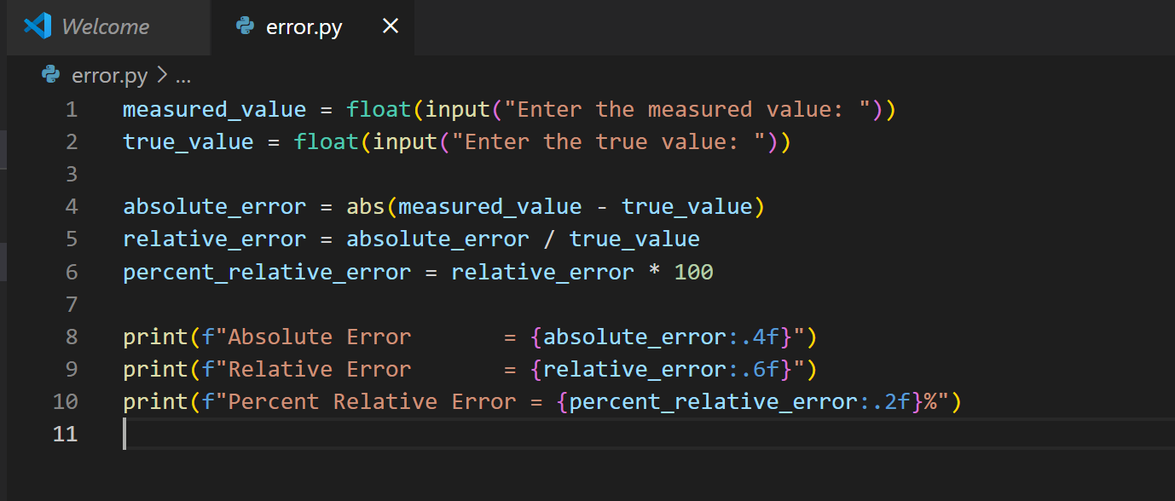
Output:
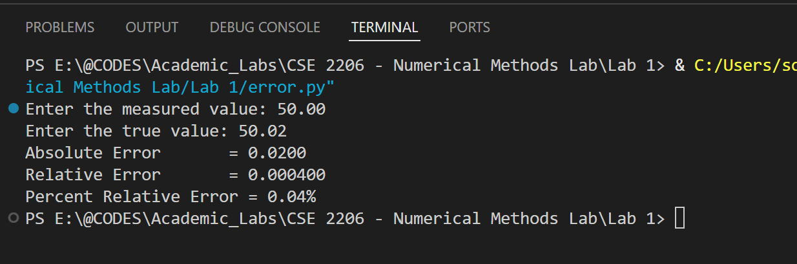

Conclusion:
From this experiment, we conclude that:
- The absolute error quantifies the direct deviation in measurement.
- The relative error and percent relative error provide a normalized measure of accuracy.
- In this case, the error values are very small, with a percent relative error of only 0.04%, which indicates that the measurement using the caliper is extremely accurate and very close to the true design value.
Thus, error analysis is an essential tool for evaluating the precision and reliability of numerical computations and experimental measurements.

